GUN CONTROL POLICY

Universal Background Checks (UBCs) and bans on felons possessing firearms are two methods of regulating firearms. While federally-licensed firearms dealers must run pre-sale background checks, the requirement does not apply to private parties (such as those found at gun shows, flea markets, or online). According to a recent national survey, “22% … of gun owners … obtain[ed] their most recent firearm … without a background check.” While 92% of Americans favor universal background checks, a UBC law that passed the U.S. House in March of 2021 has stalled in the Senate. Perhaps paradoxically in light of Congress’ hesitation over UBCs, felons are not permitted to possess a firearm, regardless of the nature of their felony. In October of 2021, the Supreme Court refused to hear a challenge to a Wisconsin law that banned even felons who committed non-violent crimes from ever owning handguns. One study shows that UBCs, felon bans, and giving more discretion to authorities to deny firearms permits can decrease shooting homicides by 29% (that equates to 4,200 lives).

What do you think? Do policies like universal background checks and banning all felons from possessing firearms (regardless of the nature of their felony), limit the right to bear arms too much?

As is the case with other fundamental rights like free speech, where the government has a compelling interest (like a interest in preventing gun violence) and narrowly tailored means (like checking the background of those who want firearms and excluding those who commit felonies - particularly those that are violent in nature) then the government is permissibly regulating the fundamental right

This question turns on the nature of a right. A right is typically inherent in the person. It does not cease to exist because of somebody's status as a felon. It would be absurd to think that felons no longer have a right to be free from unreasonable search and seizure, because that right does not cease once they become a felon. Thus, the right to bear arms is inherent in the person, and does not cease once they become a felon.

Generally, restrictions on gun ownership relating to safety are sensible measures to reduce harm. However, banning all felons from possessing firearms creates an all-too-easy charge for re-incarcerating felons who were not previously convicted of a violent crime.

Absolutely not. Policies like universal background checks and banning all felons from possessing firearms can help prohibit gun violence. Additionally, they help create a database of firearms owners. In looking at the cost-benefit analysis of this issue, the benefit of preventing gun violence weighs more heavily than the drawback of limiting the second-amendment.

HIGH CAPACITY GUNS
A “magazine” is a detachable chamber of gun that is loaded with bullets. By having multiple magazines, a gun user can quickly reload a gun once its bullets run out. A “high-capacity” magazine is one that holds more than a specified number of bullets. While most firearms sold in the U.S. carry between 12 and 15 bullets, the high-capacity threshold in the now-expired Federal Assault Weapons Ban was ten. There is widespread public support (70%) for banning high-capacity firearms, as eight states have done. Federal Circuit courts have found that such bans are reasonably fit to the important government interest of reducing gun violence. Gun rights advocates reject this conclusion. They point to studies finding no correlation between high capacity bans and gun deaths; ninety-five percent of murders involve three or fewer bullets. While high-capacity bans are correlated with fewer mass shootings, the number of incidents is too few to draw statistically significant conclusions. A petition challenging the ban in California is currently pending before the Supreme Court.

What do you think? Does the Second Amendment extend to high-capacity firearms?

When it comes to gun violence deaths, mass shootings really only make up a small portion of the violence. Most of the deaths come from suicides. However, when mass shootings do occur, they're devastating. There is no practical reason to give individuals access to high capacity guns.

The right to bear arms is in the Bill of Rights, but high capacity weaponry was never considered by the framers. Machine guns, flamethrowers, and weaponized vehicles are subject to more restrictions than hunting rifles, so the case could be made that high capacity weapons should be as well.

If there is a right to bear arms, it ought to extend to all guns, including those with high capacity. The appropriateness of individual citizens owning guns intended for only military purposes seems to me a different category than simply high/low capacity guns.

I literally cannot fathom why anyone would need such a gun but am open to hearing arguments in favor.

There is no indication that the second amendment limited magazine capacity in any way. In fact, that Congress has the power to grant letters of marque and reprisal indicates that private individuals could own any arms that the military did, and Congress could then create privateers of them.

Principles of originalism point to NOT including high magazine weapons. They didn't exist at the time of the founding and do not fit within the whole well-regulated militia thing.
RACE AND GUN REGULATIONS

In the 1960s, California allowed people to carry both open and concealed weapons in public spaces. In 1967, 30 members of the Black Panthers protested California’s police system. During the protest, the Panthers openly carried their weapons on the steps of the California Statehouse. In response, then-Governor Ronald Reagan and California legislators passed the Mulford Act. The Act made it a felony to carry any firearm, open or concealed, in public places without a governmental license. In his book, Gunfight: The Battle Over the Right to Bear Arms, Adam Winkler, a professor at UCLA Law and a specialist in American Constitutional Law argued that “the [Act] was part of a wave of laws that were passed in the late 1960s regulating guns, especially to target African-Americans.”

What do you think? Is this history relevant to critically assessing gun regulation today?

Yes, the most effective gun regulation should have a blanket effect on all members of society. However, the oppressive nature of past regulations against a specific group in society should weigh heavily into how to better craft future regulations to avoid these unsatisfactory effects.

My answer to this depends on what exactly "relevant to critically assessing" means, but if it means "relevant to making good policy," then I think not. Laws are like prophets: "Ye shall know them by their fruits."

This history highlights why the Second Amendment was limited in nature to a well-regulated militia. The history how the state interest in keeping people of color unarmed and subordinate in this country is pervasive throughout history, showing how highly unlikely it would be that southern states would have ever supported or ratified an amendment that was understood as to give each individual a right to own a gun.

I don't think that any person should have access to a gun. However, while we do have the Second Amendment right now, I think it's important to recognize that the right to possess firearms doesn't seem to extend to black people in the same way that it does to white people and that maybe some firearm regulations were put in place to limit the possibility of Black people protecting themselves or even fighting for their own rights.

As far as the United States is concerned, all issues are racial to some degree. We cannot ignore the disparate impact that our laws have on different minority groups. It is important to look not just at statutory language or intent, but also effect.

STATS ON GUN OWNERSHIP

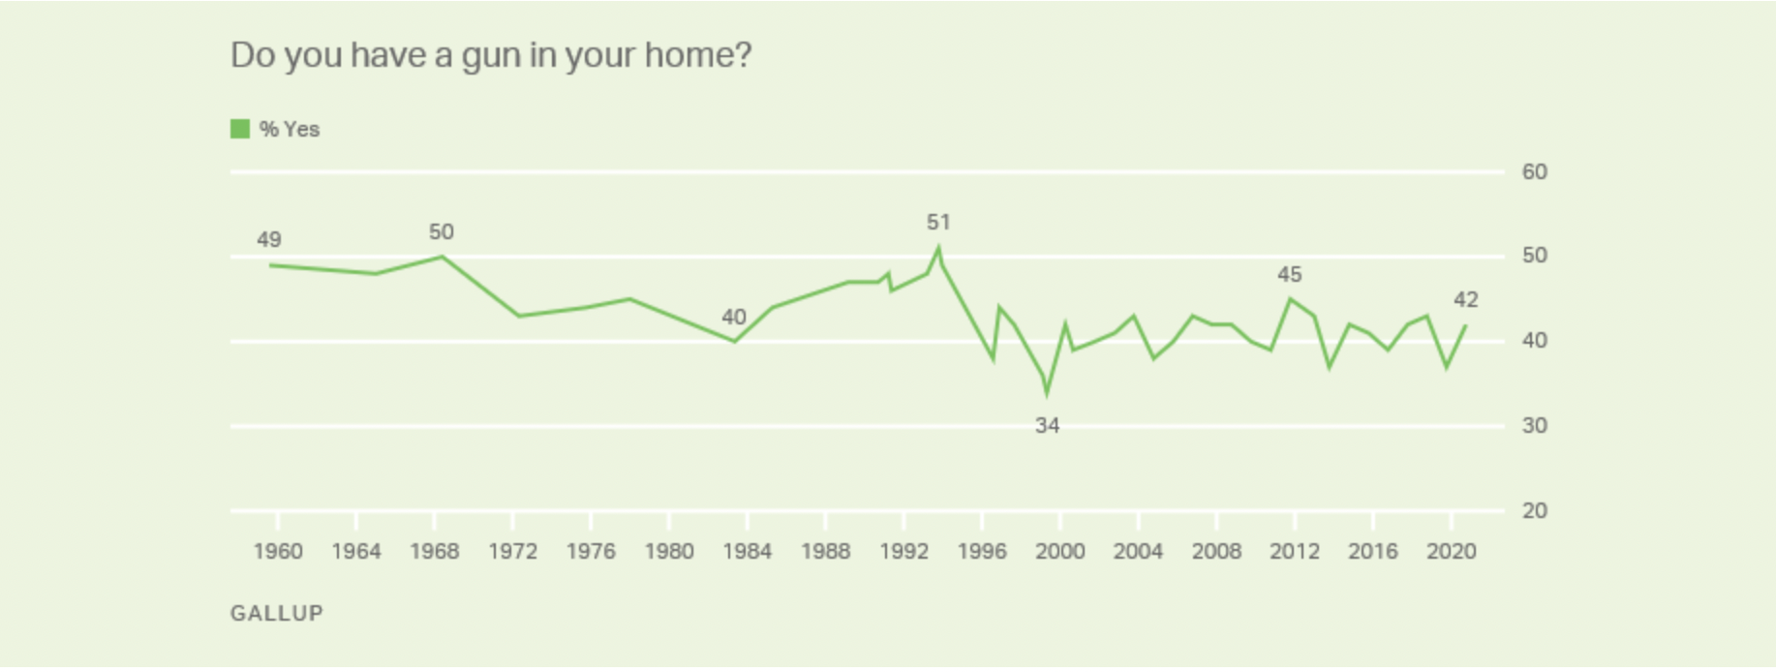

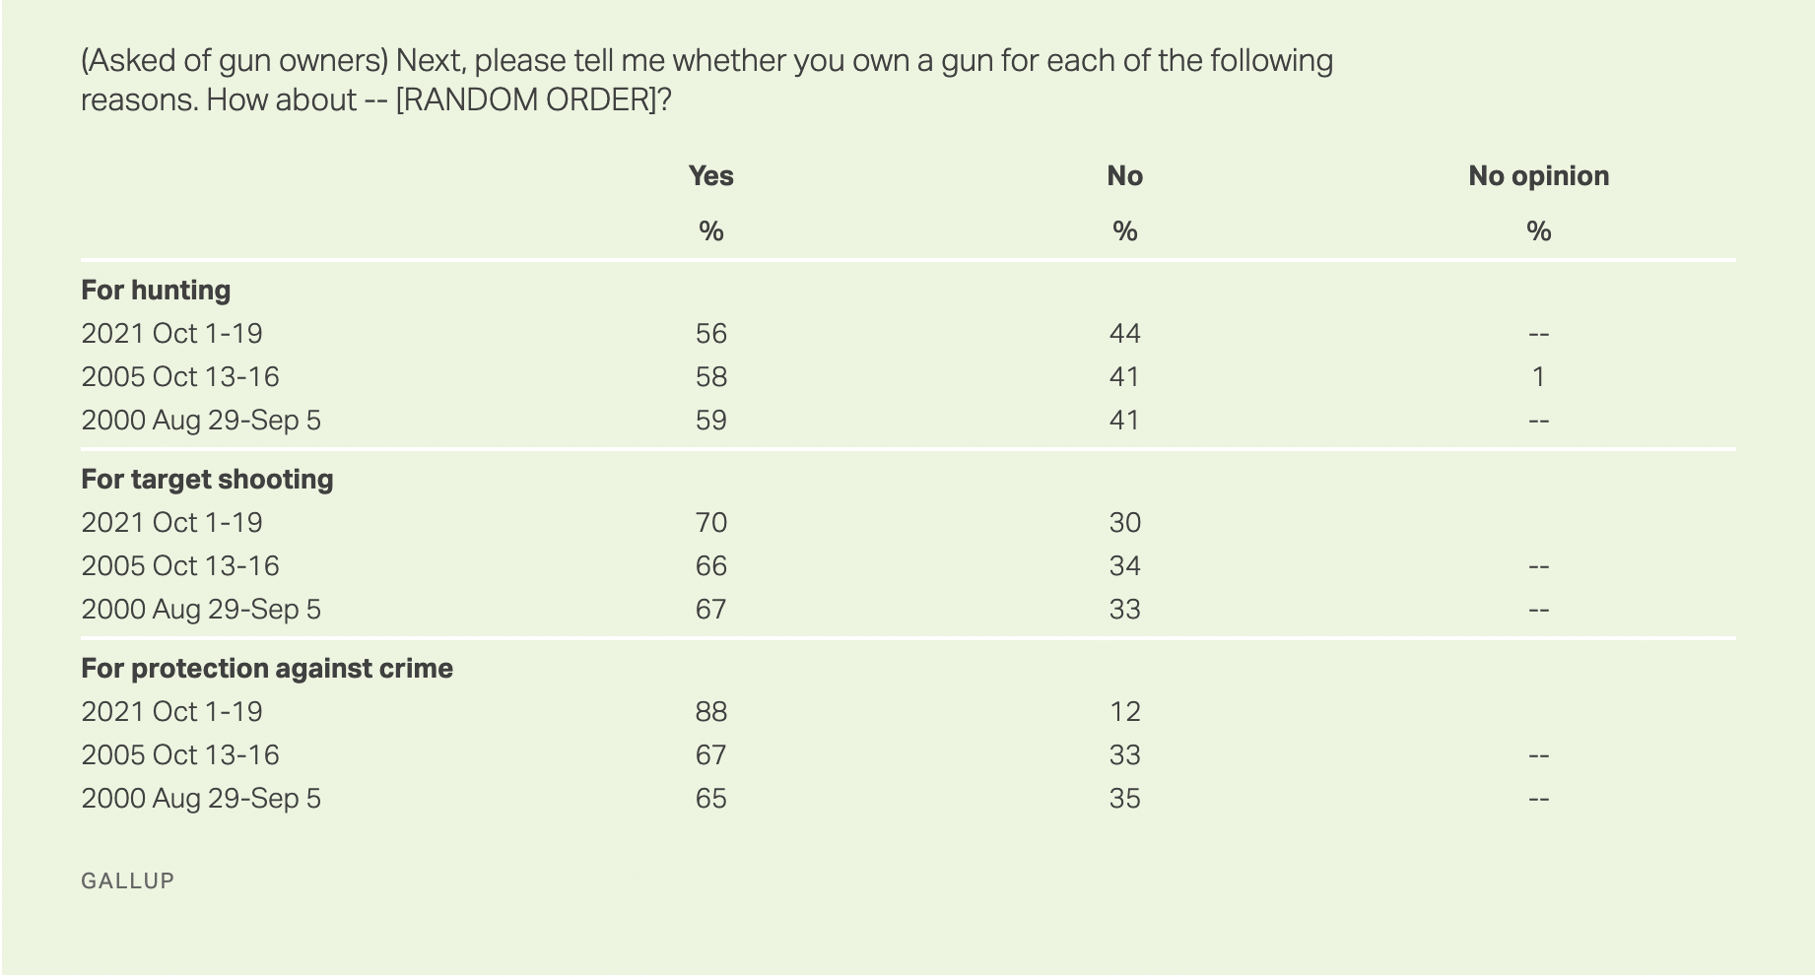

SURVEY

Add the numbers of your responses together. This will help us pair people up for discussion.

Prompt A: Do policies like universal background checks and banning all felons from possessing firearms (regardless of the nature of their felony), limit the right to bear arms too much?

1. No 2. I have no opinion or my opinion is conflicted. 3. Yes.

Prompt B: Does the Second Amendment extend to high-capacity guns?

1. No 2. I have no opinion or my opinion is conflicted. 3. Yes.

Prompt C: According to some scholars, many gun regulations were passed to oppress African Americans. Is this history relevant to critically assessing gun regulation today?

1. No 2. I have no opinion or my opinion is conflicted. 3. Yes.

Miller, M., Hepburn, L., & Azrael, D. (2017). Firearm acquisition without background checks. Annals of Internal Medicine, 166(4), 233. https://doi.org/10.7326/m16-1590
Gallup. (2022, February 18). Guns. Gallup.com. Retrieved April 1, 2022, from https://news.gallup.com/poll/1645/guns.aspx
Birenbaum, G. (2021, March 11). The house just passed universal background checks for gun sales - again. Vox. Retrieved April 1, 2022, from https://www.vox.com/2021/3/11/22319705/universal-background-checks-house-thompson-murphy
18 U.S.C. 922(g)(1)
Fritze, J. (2021, October 5). Supreme Court declines to take Felon's Second Amendment Challenge to Lifetime Gun Ownership Ban. USA Today. Retrieved April 1, 2022, from https://www.usatoday.com/story/news/politics/2021/10/04/supreme-court-declines-challenge-gun-ownership-ban-felons/5895319001/
ABC News Network. (n.d.). 'Ghost guns' showing up in school shootings, experts fear trend will get worse. ABC News. Retrieved April 1, 2022, from https://abcnews.go.com/US/ghost-guns-showing-school-shootings-experts-fear-trend/story?id=83346844

